Using the

8-bit blocks, private key= {2,7,11,21,42,89,180,354}, multiplier n = 588, modulus m = 881.

plaintext = b”Hi” (binary value, similar that what you will read from your file)

Public key:

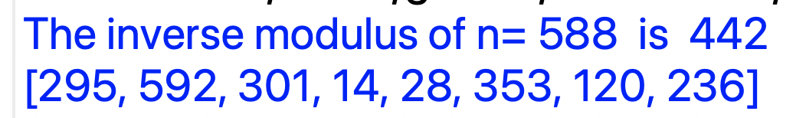

Ciphertext = [620,1157)

Here is how I decrypted it:

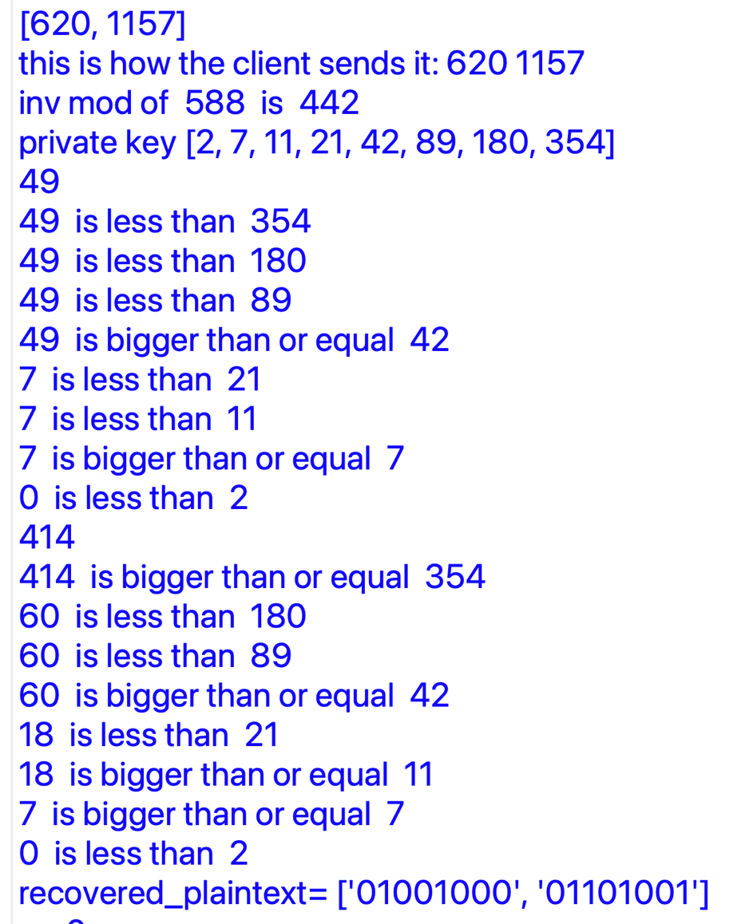

I had binary strings, so I converted them to numbers (integers)

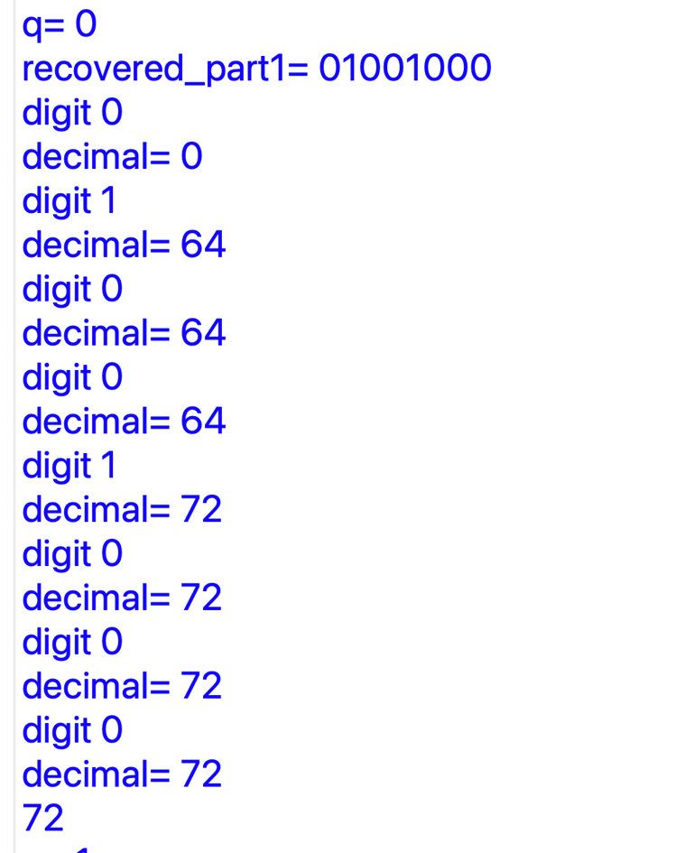

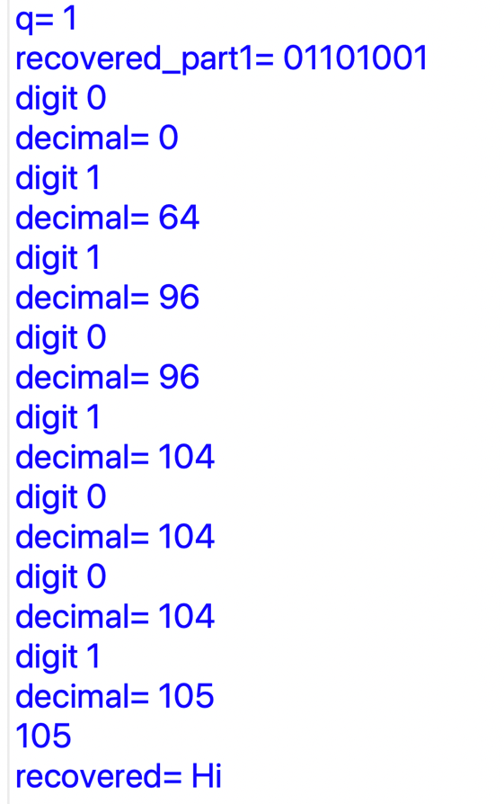

Here is an example that Ross did using the same keys:

plaintext = b”Hello”

ciphertext = [620, 1482, 1274, 1274, 1630]

